Chapter 9

Exercise Solutions

Ex 9.1
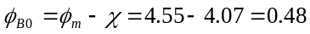V
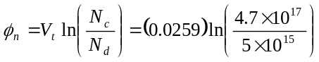
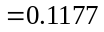V
V
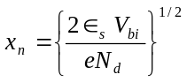
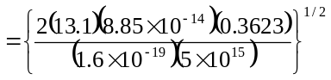
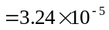cm
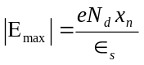
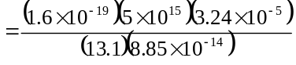
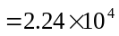V/cm
_______________________________________

Ex 9.2
From Figure 9.3,
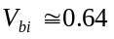V
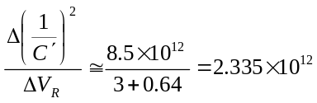
Then 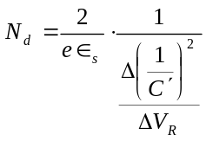
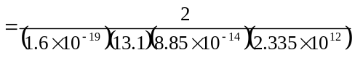
or 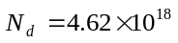cm
_______________________________________

Ex 9.3
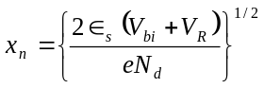
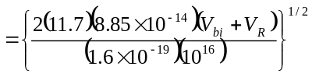
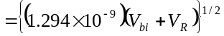
- 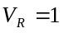V, 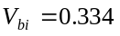V
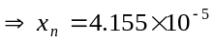cm
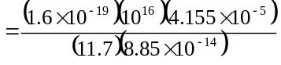
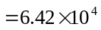V/cm
Then 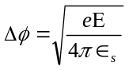
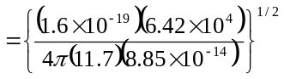
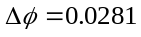V
- 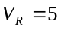V,
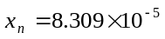cm
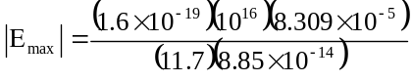
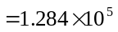V/cm
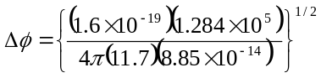
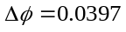V
_______________________________________

Ex 9.4
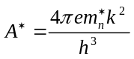
Assume 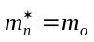, then
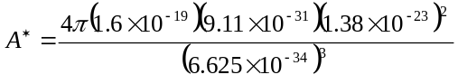
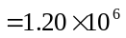A/K-m
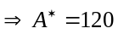A/K-cm
_______________________________________

Ex 9.5
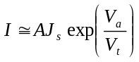
so that 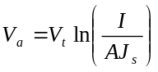
For the pn junction:
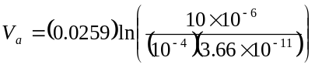
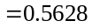V
For the Schottky junction:
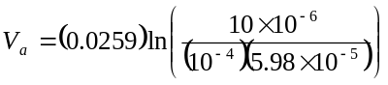
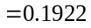V
_______________________________________

Ex 9.6
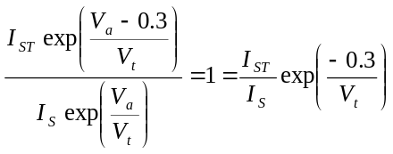
Then
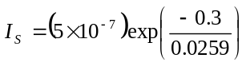
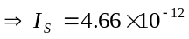A
_______________________________________

Ex 9.7
We have
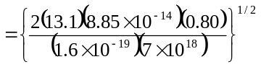
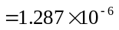cm
or 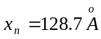
_______________________________________

Ex 9.8
From Example 9.8, 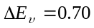eV.
We find
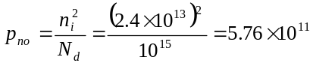cm
Now

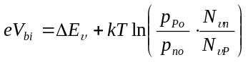
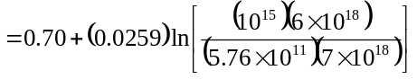
or 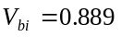V
_______________________________________

Test Your Understanding Solutions

TYU 9.1
- 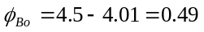V
- 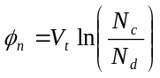
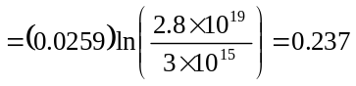V
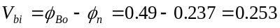V
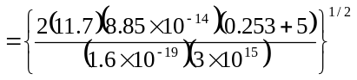
or 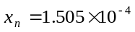cm
Then
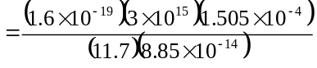
or 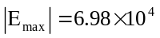V/cm
- 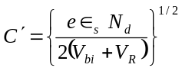
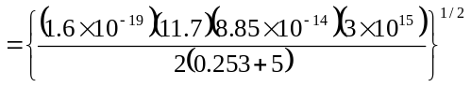 or 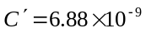F/cm
_______________________________________

TYU 9.2
- 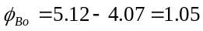V
- 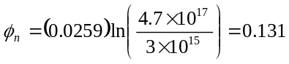V
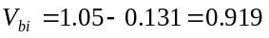V

- 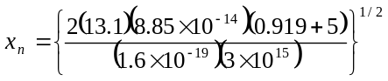
or 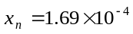cm
Now
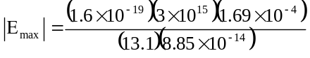
or 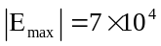V/cm
- 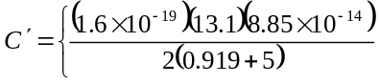
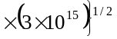
or 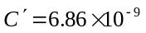F/cm
_______________________________________

TYU 9.3
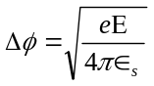
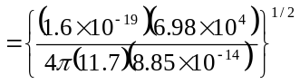
or 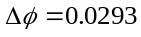V
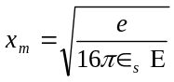
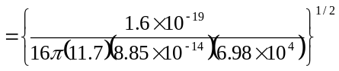
or 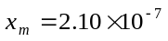cm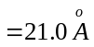
_______________________________________

TYU 9.4
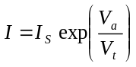
Then
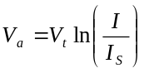
- For the pn junction diode
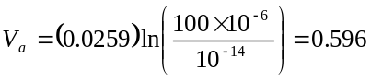V
For the Schottky diode
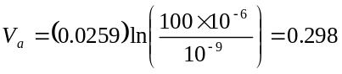V

- For the pn junction diode
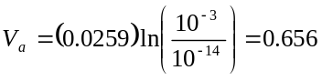V
For the Schottky diode
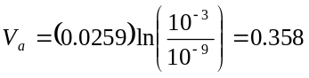V
_______________________________________

